[Full Paper Title, Bold ‘Times New Roman’, Font Size 12]
Author 1^{1*}, Author 2¹, Author 3², Author 4¹ [corresponding author is shown with *]
¹Authors’ Affiliations, City, Country
²Authors’ Affiliations, City, Country
*Corresponding Author (corresponding author’s email address in parentheses)
[‘Times New Roman’ font size 12]

Abstract
[‘Times New Roman’ font size 11. Abstract should be between 250-350 words, and should explain the key concepts of the research.]

Keywords: [Please use less than five keywords. Each keyword should be capitalized]

- First Section Title

The full manuscript should be between 8 to 10 pages. The manuscript should use standard 8.5” × 11” paper with 1-inch margins (top, bottom, left, right). All text should use ‘Times New Roman’ font style, and the body of the manuscript should use size 11 font. For font size of headings, please refer to Table 1. Paragraphs should not be indented, and there should be a line space between each paragraph. Tables should be provided in an editable format. In-text citations should use the "Author (Year)" format.

Subsection Title

Sample Heading (Third Level). Only two levels of headings should be numbered. Lower-level headings remain unnumbered; they are formatted as run-in headings. The following Table 1 gives a summary of all heading levels. Tables should be centered.

Table 1: Table captions should be placed above the tables, centered size 11 font.
Heading level | Example | Font size and style
Title (centered) | Lecture Notes | 14 point, bold
1st-level heading | Introduction | 12 point, bold
2nd-level heading | Printing Area | 11 point, bold
3rd-level heading | Run-in Heading in Bold. Text follows | 11 point, bold
4th-level heading | Lowest Level Heading. Text follows | 11 point, italic

Equations in the manuscript should be centered and set on a separate line. Use Microsoft Equation Editor to produce equations and provide them in an editable format within the text.

$2x+6=y$ (1)

Figures produced in special software shall have a high-resolution image (600DPI). Authors are responsible for ensuring the clear presentation of any numbers or text in figures before the acceptance of their manuscript. Figures and figure captions should be centered.

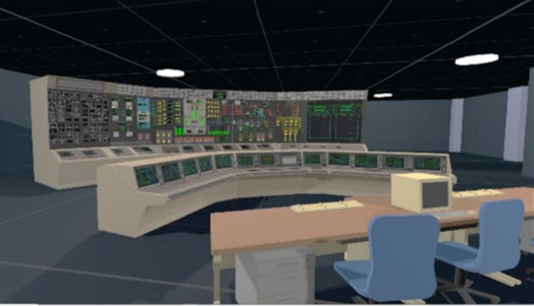
Figure 1: Figure captions should be placed under the figures, size 11 font.

The following bibliography provides a sample reference list with entries for conference papers (Hirosea et al., 2022) and journal articles (Xu et al., 2018). The references in the bibliography should be formatted to size 11 font with 6pt spacing after the paragraph.

Acknowledgement
Acknowledgments should be placed at the end of the manuscript before the reference section.

References
Hirosea, A., D. Takedaa, K. Nonosea, and K. Tasakaa. An Exploratory Study on Decision to Main Control Room Abandonment due to Fire-Induced Loss of Habitability: Using a VR Nuclear Power Plant Main Control Room Simulator. in Probabilistic Safety Assessment and Management, PSAM 16, 2022. Honolulu, Hawaii.
Xu, J., Z. Tang, X. Yuan, Y. Nie, Z. Ma, X. Wei, and J. Zhang, A VR-based the emergency rescue training system of railway accident. Entertainment Computing, 2018. 27: p. 23-31.

